Chapter 15, Problem 45.

Given 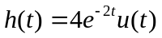 and 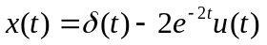, find y(t) = x(t)*h(t).

